**Overview:**

Hi! Welcome to the StepWise overview document. I’ll be your guide as we explore the software together.

StepWise is a suite of products that are owned by the company Optum. BCBSAZ has previously installed the StepWise Rating tool. The rating tool was only accessible to internal users and was managed by members of the Actuarial and Sales groups. As an expansion to this, BCBSAZ is not implementing the StepWise Quoting tool.

The Quoting tool is being stood up to remove some of the manual process that our Small Group sales team experiences. The tool will allow Brokers to enter the system and generate a quote without having to contact BCBSAZ. Once things are finalized with the group, the quote will be submitted to Underwriting for continued processing. This will expedite the process in enrolling small groups and allow for potentially higher conversion/turn. It will also allow members of the Sales and Actuarial teams to utilize the software, create calculations, etc.

**Server Prerequisites:**

In order for the software to function correctly, there are a number of prerequisite pieces of software and server side permissions. These are listed below as reference as if they are missing or corrupt can impact the app.

**Software:**

Microsoft Excel – Must be installed/started under the service account in order to be accessible by the app.

Microsoft Word - Must be installed/started under the service account in order to be accessible by the app. Utilized for the quote generation.

PDF Generator – A PDF generator is required in order to convert the quote to PDF. The quote will be created in a Word template and then printed as a pdf by the software to be available to the Broker. The PDF printer will either be the GhostScript PostScript Printer or the standard Microsoft PDF printer, depending on the server.

**Windows Server Configuration:**

The Optum software installation guide does a really good job of calling out all of the correct settings that must be configured. I would reference that document in order to capture the most up to date requirements. One big configuration item is IIS. As this is a site managed via a web UI, the IIS configuration is important and will allow for any binding of BCBSAZ sites. IIS configuration will also be important as new servers are built. Stock IIS configurations dictate that the service restart every 29 hours. If this is not changed to a scheduled time, we could run into issues with the IIS restarting and booting all users out. IIS configuration is managed by the Server Services team, we just need to be aware of it as a possible pain point.

**Environment Inventory:**

**Dev:**

The intent of the development environment is twofold. In the Rating tool, initial information is loaded into Dev for review, essentially starting the process. In the Quoting tool, the development environment is the lowest tier environment where changes are applied and tested before being promoted. This will include changes to formulas and calculations made by the business.

**MD-STP-A01:** Comingled application server containing the Rating and Quoting tools. This server contains the Stepwise, Sandbox, Test, and Test2 instances for the Rating engine. This server contains the Stepwise_Shop instance for the Quoting Engine. The software installation is configured for NT Authentication. Security has been configured for this application. 1 service account controls all of the application functions. This accounts runs the services and controls all interactions with the database. The account information is stored in CyberArk.

**MD-STP-D01:** Database server containing all of the databases for the Rating and Quoting tools. Each instance of the software has 3 databases associated with it; the main transactional database, an admin database, and a logging database. This server contains the Stepwise, Stepwise_Admin, Stepwise_Logging, StepWiseSandbox, StepWiseSandbox_Admin, StepWise_Sandbox_Logging, StepwiseSummary, StepWiseTest, StepWiseTest_Admin, StepWiseTest_Logging, StepWiseTest2, StepWiseTest2_Admin, and StepWiseTest2_Logging databases for the Rating engine. This server also contains the StepWiseShop, StepWiseShop_Admin, and StepWiseShop_Logging databases for the Quoting engine. In addition to the databases for the Stepwise tools, the Actuarial, EnrollmentRepl, SMSSRepl, and VitalRepl databases are held here also. These are used as sources for other Stepwise tables. INSERT INFO ON HOW HERE.

**Security:** NT Authentication based on the binding of AD groups to Stepwise created roles. Additional information on Security is provided later in this document.

**Installation And Additional Configuration:** Information on the installation of the software and initial configuration of it is found in the BCBSAZ installation documentation. Installation and configuration will vary by environment.

**QA:**

The intent of the QA environment is twofold. In the Rating tool, initial information is promoted from the Dev environment for additional review by other teams. In the Quoting tool, the QA environment is where changes are promoted to and where user QA occurs.

**MU-STP-A01:** Comingled application server containing the Rating and Quoting tools. This server contains the Stepwise instance for the Rating engine and the Stepwise_Shop NT and SSO instances for the Quoting Engine. The software installation is configured for both NT and SSO Authentication. Security has been configured for this application. 1 service account controls all of the application functions. This accounts runs the services and controls all interactions with the database. The account information is stored in CyberArk.

**MT-STP-D01:** Database server containing all of the databases for the Rating and Quoting tools. Each instance of the software has 3 databases associated with it; the main transactional database, an admin database, and a logging database. This server contains the Stepwise, Stepwise_Admin, and Stepwise_Logging, databases for the Rating engine. This server also contains the StepWiseShop, StepWiseShop_Admin, and StepWiseShop_Logging databases for the Quoting engine. While there are 2 application instances, they both connect to the same backend database. In addition to the databases for the Stepwise tools, the Actuarial, EnrollmentRepl, SMSSRepl, and VitalRepl databases are held here also. These are used as sources for other Stepwise tables. INSERT INFO ON HOW HERE.

**Security:** NT Authentication is based on the binding of AD groups to Stepwise created roles. SSO Authentication is based on the cookie created when a Broker signs in through the Broker Portal. Additional information on Security is provided later in this document.

**Installation And Additional Configuration:** Information on the installation of the software and initial configuration of it is found in the BCBSAZ installation documentation. Installation and configuration will vary by environment.

**Stage:**

The Stage environment breaks from what we have seen in the lower environments. In the Stage environment, the Rating and Quoting engines are each installed on separate servers. This is designed to create a more Production like environment. It will also allow us to performance test each of the applications separately and adjust the servers independently. Go forward, additional servers can be added to this environment in order to make it more robust as we grow the environment.

**MS-STP-A01:** Dedicated application server for the Quoting tool. This server contains the Stepwise_Shop instance for the Quoting Engine. The software installation is configured for NT Authentication and also SSO (single sign on) for our Broker partners to enter the software. NT users will enter via a desktop link that is being pushed out to the BCBSAZ Favorites Links (should redirect or allow access to the same page as (https://azblueshopInternal.stage.secure.azblue.com/StepWiseShop/CommonUI).

Brokers will enter the system via the Broker Portal (https://azblueshop.stage.secure.azblue.com/StepWiseShop/CommonUI). After entering the Broker Portal, they will click on a link for the Quoting Tool. The initial traffic request will go through a NetScaler appliance and then to the IIS ARR Proxy Server in the WDF domain. It is important that the Broker be constantly routed to the same server. This will then route the traffic to the application server. Because there is only 1 server at this point, sticky session configuration is not required.

The Enterprise Software Services team has created SSL certificates that are required for this configuration to work correctly. Security has been configured for this application. 1 service account controls all of the application functions. This accounts runs the services and controls all interactions with the database. The account information is stored in CyberArk.

**MS-STP-A02:** Dedicated application server for the Rating tool. This server contains the Stepwise instance for the Rating engine. The software installation is configured for NT Authentication. The site http://stepwisestage/StepWise/app/home.aspx has been created for this environment. Security has been configured for this application. 1 service account controls all of the application functions. This accounts runs the services and controls all interactions with the database. The account information is stored in CyberArk.

**MS-STP-D01:** Database server containing all of the databases for the Rating and Quoting tools. Each instance of the software has 3 databases associated with it; the main transactional database, an admin database, and a logging database. This server contains the Stepwise, Stepwise_Admin, and Stepwise_Logging, databases for the Rating engine. This server also contains the StepWiseShop, StepWiseShop_Admin, and StepWiseShop_Logging databases for the Quoting engine. While there are 2 application instances, they both connect to the same backend database. In addition to the databases for the Stepwise tools, the EnrollmentRepl database is held here also. It is used as a source for other Stepwise tables. INSERT INFO ON HOW HERE.

**Security:** NT Authentication based on the binding of AD groups to Stepwise created roles. Broker security is managed through the Broker portal. Brokers coming through the broker portal will pick up a cookie that contains all of the application security information. They will be passed into the SSO instance which will validated that information and assign them a session. Additional information on Security is provided later in this document.

**Installation And Additional Configuration:** Information on the installation of the software and initial configuration of it is found in the BCBSAZ installation documentation. Installation and configuration will vary by environment.

**Production:**

This is the final Production environment that all users will interact with. The environment consists of a set of load balanced app servers for each application and a database server that all 4 app servers interact with.

**MP-STP-A01:** Dedicated application server for the Rating tool. This server contains the Stepwise instance for the Rating Engine. 1 service account controls all of the application functions. This accounts runs the services and controls all interactions with the database. The account information is stored in CyberArk. Not much is known about this environment as it has predominantly been administered by the business. ***Go forward, we’ll need to better understand the security modeling and how the applications all function.***

**MP-STP-A02:** Mirrored sever of MP-STP-A01 for load balancing.

**MP-STP-A03:** Dedicated application server for the Quoting tool. This server contains the Stepwise_Shop instance for the Quoting Engine. The software installation is configured for NT Authentication and also SSO for our Broker partners to enter the software. NT users will enter via a desktop link that is being pushed out to the BCBSAZ Favorites Links (should redirect or allow access to the same page as (https://azblueshopInternal.secure.azblue.com/StepWiseShop/CommonUI). The traffic will then go through another NetScaler appliance with sticky sessions configured on it. This will then route the traffic to the application server in the Corp domain that the user already is working on (should such a condition exist). This should ensure that they do not lose any information due to orphaned sessions.

Brokers will enter the system via the Broker Portal (https://azblueshop.secure.azblue.com/StepWiseShop/CommonUI). After entering the Broker Portal, they will click on a link for the Quoting Tool. The initial traffic request will go through a NetScaler appliance and then to the IIS ARR Proxy Server group (6 servers in the group) in the WDF domain. It is important that the Broker be constantly routed to the same server. The traffic will then go through another NetScaler appliance with sticky sessions configured on it. This will then route the traffic to the application server in the Corp domain that the Broker already is working on (should such a condition exist). This should ensure that they do not lose any information due to orphaned sessions.

The Enterprise Software Services team has created SSL certificates that are required for this configuration to work correctly. Security has been configured for this application. 1 service account controls all of the application functions. This accounts runs the services and controls all interactions with the database. The account information is stored in CyberArk.

**MP-STP-A04:** Mirrored sever of MP-STP-A03 for load balancing.

**MP-STP-D01:** Database server containing all of the databases for the Rating and Quoting tools. Each instance of the software has 3 databases associated with it; the main transactional database, an admin database, and a logging database. This server contains the Stepwise, Stepwise_Admin, and Stepwise_Logging, databases for the Rating engine. This server also contains the StepWiseShop, StepWiseShop_Admin, and StepWiseShop_Logging databases for the Quoting engine. In addition to the databases for the Stepwise tools, the EnrollmentRepl database is held here also. It is used as a source for other Stepwise tables. INSERT INFO ON HOW HERE.

**StepWise Shop Security:**

There are 2 security components for the Stepwise Quoting engine. 1 component allows Brokers to connect via the Broker Portal. The second component allows authenticated internal users to access the system. For the remainder of this document, only the Quoting tool is documented. The Rating engine security is not documented and will need to be understood for potential future phases of the StepWise project.

**Broker Security:** Brokers initially access the application via the Broker Portal. If a Broker does not have access to the Broker Portal, they will not be able to access the Quoting tool at all. A web cookie will be issued to them that is named AZBFRXSS and has rights to the .azblue.com domain upon successful login to the portal. Once accessing the portal, they’ll be able to click on a link that will take them to the StepWise Quoting page. The StepWise application will then decrypt and parse the cookie to get the Broker credentials. There will be a group in the Authorization Manager named SSOBroker which will be assigned the Broker role in order for them to work within the system.

The Broker cookie has a number of properties that are available. They include: Email, FirstName, LastName, SSORoleName, BrokerNPN, FirmNPN, SSOBrokerRole, SSOStatus, SSOUserId, SSOUserName. These properties are all parsed out by the StepWise application and available to it.

Broker Role: Insert what this drives within the app and why it is important.

Everyone (Extension) Role: Insert what this drives within the app and why it is important.

**Internal User Security:** Internal users will gain access by being added to AD groups. These AD groups will be mapped in the application and will have a specific StepWise role assigned to them. This will allow them to act within the application. The user groups are all defined below. Additionally, an overview of the scope of permissions by group in each environment is provided. New users that need to be added will be done via a Serving Blue ticket. INSERT SERVING BLUE DOCUMENTATION HERE.

**ACL_SQL_STP_INTTST:** This AD group contains all of the standard users from the business. This group will utilize the application but not have any administrative functions available to them. The same level of database permissions will be available across all 3 databases associated with the StepWise instance.

**ACL_SQL_STP_INTBDE:** This AD group contains all of the Business Development Executives from the business. This group will utilize the application but not have any administrative functions available to them. The same level of database permissions will be available across all 3 databases associated with the StepWise instance. The BDE members are separated out as Optum has created a process that links the member to the Brokers that they manage so that they only see those records.

**ACL_SQL_STP_INTSUP:** This AD group contains the Super Users of the application. They will have more permissions within the application than the standard user group, but will not has as many as the internal business owners.

**ACL_SQL_STP_INTOWN:** This AD group contains the Internal Business Owners of the application. This group will function as the administrators in the business capacity. They will be responsible for data loads and formula development within the application. They will also have access to the virtualized software that is being pushed to the users.

**ACL_SQL_STP_IT_SUPPORT:** Members of the VAM team are in this group. This group will have the System Administrator role in StepWise. They will be able to access all of the functions and all logging will indicate the NT account that drove it.

**Integrations:**

An integration has been created by Optum between the new Quoting tool and existing Rating tool. The intent of the Integration is to generate a rating for the quote once it has been finalized. The integration will take the information from the quoting tool, transform it using a custom XLST template, and use the newly created XML document to load into the rating tool.

Because the integration is custom, there are a couple of pieces to be aware of. The first is the XLST template. If this template is altered, deleted, etc. This will cause the integration to fail. The second portion are custom system parameters in the quoting tool. These parameters are all configured to allow the integration to work correctly. The final part is the user account in the rating tool. A specific user account with the correct permissions must be set up in the rating tool in order to process the information in correctly.

**Administrator Tools:**

**StepWise Diff Scripter:** Used to script differences between different environments for comparison.

**StepWise Diff Viewer:** Used to view differences between objects. This allows you to compare what an object looked like historically and post changes. This can be used for troubleshooting to track which user and change has caused a particular behaviour to occur.

**StepWise Formula Designer:** Used to create the formulas that can be utilized in the application. Factor tables and value lists are displayed within the application which can then be used to create these formulas. This also allows you to create value lists that can be populated within the application.

**Important Web Interfaces:**

**Management Studio:** http://MACHINENAME/StepWiseShop/ManagementStudio. The machine name will change by environment. The management studio is the main landing page that also links out to the other studio components. Key areas include:

**Migrator:** Used to migrate packages and changes across environments and show migration history.

**Service Manager:** Allows via the UI for the services to be stopped and restarted. This area also allows you to view and manage deleted quotes.

**Security Manager:** Takes you to the Security portal where all things security are managed.

**Batch Processing:** Allows access to view and manage all batch processing of quotes.

**Logging And Profiling:** Allows for the application level logs to be viewed.

**Activity Logger:** Takes you to the Activity Logger portal where all quote logging can be configured.

**Web Interface:**

**Visual Topology:**

**Dev:**



**QA:**

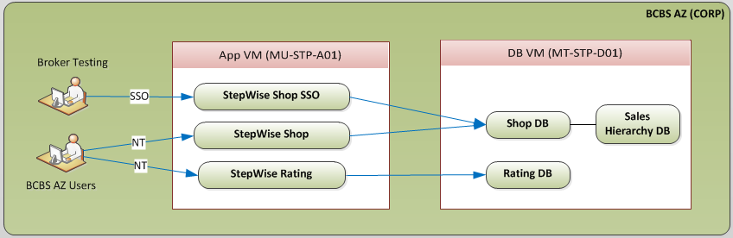

**Stage:**

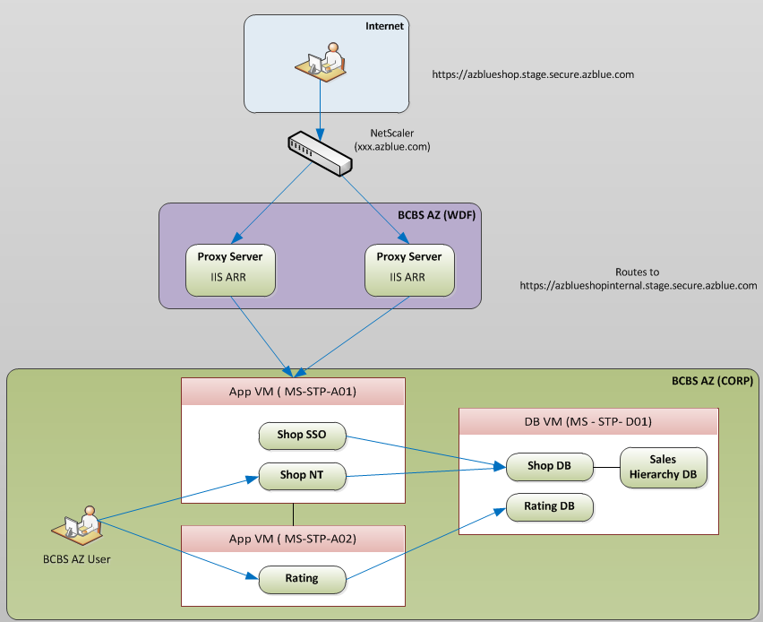

**Production:**

